BALFOUR 100
JEWISH COMMUNITY
ACTIVITIES AND EVENTS FUND

FUNDING AVAILABLE FOR EDUCATIONAL & CULTURAL ACTIVITIES MARKING THE CENTENARY OF THE BALFOUR DECLARATION

GRANTS UP TO £500
(LARGER AMOUNTS CONSIDERED FOR CENTRAL EVENTS)

SIMPLE APPLICATION FORM

FIRST DEADLINE 30TH JUNE 2017

THE BALFOUR DECLARATION, 2ND NOVEMBER 1017
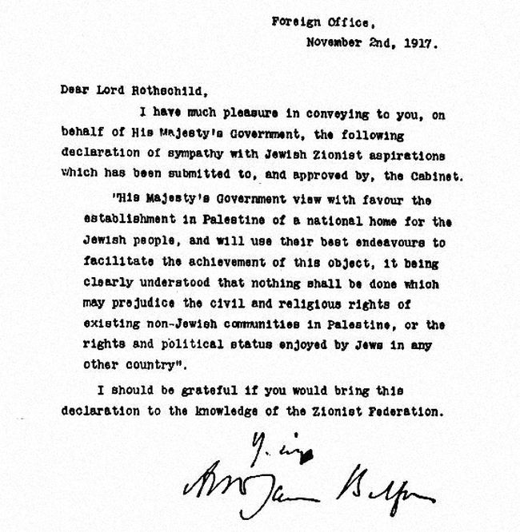
March 2017

Balfour 100 Steering Committee: Jewish Community Activities and Events Fund
This form is available to download at: www.balfour100.com/resources

Dear Jewish Community Organisation,

As you will be aware, the 100th anniversary of the Balfour Declaration takes place on 2nd November 2017. The Balfour 100 Steering Committee has established a fund (overseen by UJIA) to support communal activities marking this centenary. The activities will form part of a wider programme of communal events. Proposals to the fund should reflect the intent and aspirations expressed on the official website of the British Jewish community: www.balfour100.com. Activities will celebrate Britain’s historic contribution to the founding of the State of Israel and showcase the British Jewish Community’s pride in its connection to Israel.

Small grants up to £500 (larger grants will be considered for central events) are available according to the following criteria (all activities will need to meet the requirements of ‘charitable purposes’):
- An event/activity that celebrates the centenary which has clear educational or cultural content e.g. Speaker (we are able to recommend speakers on request), informal educational programme, publications – the grant will be used to cover these activities;
- We will also fund reasonable additional costs around the educational or cultural event/activity including marketing and refreshments;
- Payment will be made against full receipts and a brief one-page report of the event;
- All events should take place between August-December 2017.

We welcome applications from synagogues, youth groups, schools, JACs, and other Jewish communal organisations (whether or not they are registered charities).

Applications should be made on the Application Form below and emailed to: shellie.wilks@ujia.org or sent to Shellie Wilks, UJIA, 1 Torriano Mews, Kentish Town, London, NW5 2RZ. If you would like to discuss an application or hear suggestions for activities, please email your phone number and we will return your call.

Applications for the limited funds available should arrive no later than 30th June 2017 and will be processed on a ‘first come, first served basis’. Later applications will be considered subject to the availability of remaining funds. We will provide written confirmation of the grant award, including the amount and the specific purpose of the award, by the end of July 2017.

The types of activities that we anticipate may include, but are not limited to, the following:
- Speaker/Lecture
- Speaker and Meal
- Shabbat Event
- Discussion Group
- Educational Publication
- Cultural Event
- Panel on relevance of the Balfour Declaration today and associated topics
- Summer or Winter Camp Activity
- Jewish Assembly in School

Activities must be acknowledged as part of the Balfour 100 programme and use the official logo (below).

Grants will be issued against receipts and a very short one page Report Form (please see below).

Dr Roy Graham
(UJIA Programme and Planning Director/Balfour 100 Education Sub-Group)
BALFOUR 100 EDUCATIONAL ACTIVITIES
APPLICATION FORM
APPLYING ORGANISATION:
CONTACT PERSON AND POSITION HELD:
TELEPHONE: |  |  | EMAIL:
ADDRESS OF ORGANISATION:

NAME OF EVENT & PROGRAMME OUTLINE AND DESCRIPTION:

DATE OF EVENT:
LOCATION OF EVENT:
ANTICIPATED NUMBERS AND TARGET POPULATION (APPROX):
OVERALL BUDGET: | AMOUNT: | COMMENTS (if required):
SPEAKER FEE:
REFRESHMENTS:
ROOM HIRE:
TRAVEL:
MARKETING:
MATERIALS:
OTHER:
OTHER:
OTHER:
TOTAL:
AMOUNT REQUESTED FROM THE FUND

NAME: SIGNED: DATE:__________

PLEASE SEND TO: SHELLIE WILKS: 1 TORRIANO MEWS, KENTISH TOWN, LONDON, NW5 2RZ or email
shellie.wilks@ujia.org
BALFOUR 100 EVENT REPORT FORM
ORGANISATION:
CONTACT PERSON:
TELEPHONE:
NAME OF EVENT:

DATE OF EVENT:
LOCATION OF EVENT:

NUMBERS WHO ATTENDED:
BRIEF PROGRAMME SUMMARY AND EVALUATION:

EXPENDITURE:
1. PLEASE LIST EACH ITEM AND THE AMOUNT SPENT AND BE SURE TO ATTACH ALL RECEIPTS):
2. PLEASE NOTE THAT THE MAXIMUM GRANT TOWARDS THE OVERALL COST IS £500 – THE AMOUNT OF THE AWARD WAS SENT TO YOU.
(PLEASE ATTACH INVOICE WITH BACS DETAILS AND APPROPRIATE TAX DETAILS)

NAME: SIGNED: DATE:__________

PLEASE RETURN WITHIN THREE WEEKS OF THE EVENT/ACTIVITY – THANK YOU.

PLEASE SEND TO: SHELLIE WILKS, UJIA, 1 TORRIANO MEWS, KENTISH TOWN, LONDON, NW5 2RZ OR EMAIL TO: shellie.wilks@ujia.org

